FF_5 - FF_5 - Import Electronic Bank Statement

Functionality
Using this function you can import bank statements into the system and then process them. This report can perform automatic postings or create batch input session. It posts to G/L accounts and to sub-ledger accounts.
You can specify whether both sessions should be created in one run or only the session for G/L accounting first.
For incoming payments, the notes to payee lines of the account statement can be searched either for document numbers or reference document numbers by specifying the selection field (BELNR or XBELNR). Thus, the relevant information for clearing customer payments is obtained.
If you do not specify a selection field, the note to payee fields are not interpreted and you need to clear open items manually (use transaction FEBA – Postprocess)
For outgoing payments, the system always searches for the document number.

Scenario
You’ve received files that contain bank statement from your bank and now you want to use this information to post bank statement.

Requirements
Electronic bank statement.

Menu Path | Accounting → Financial Accounting → Banks → Incomings → Bank Statement → FF_5 - Import
Transaction Code | FF_5

1. Double Click on FF_5 – Import.

Bank Statement: Various Formats (SWIFT, MultiCash, BAI...)

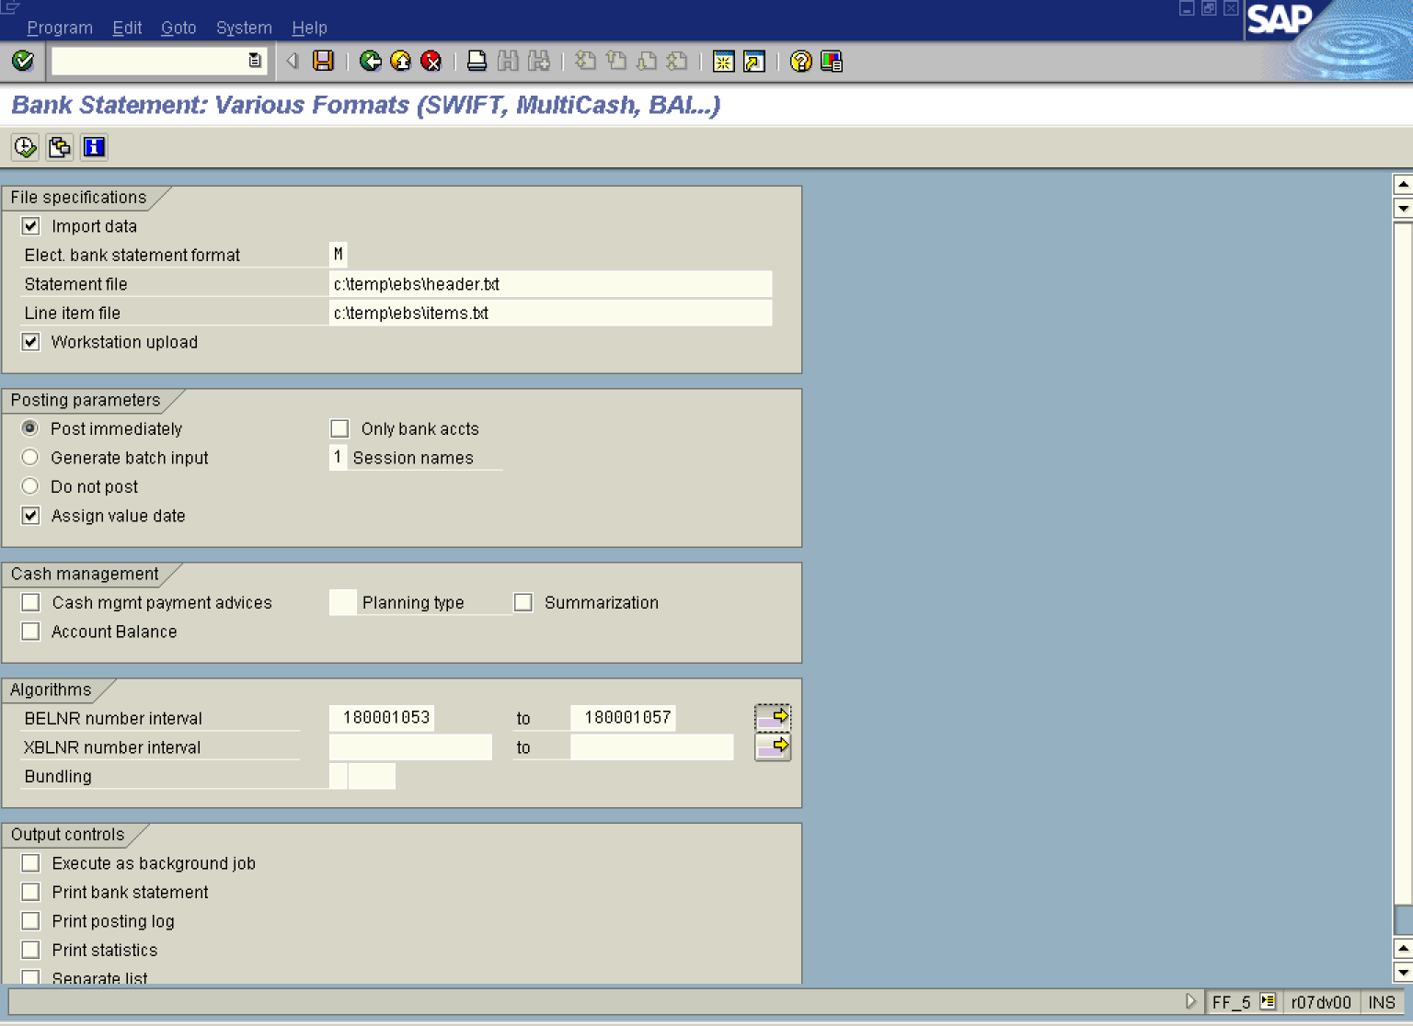

2. Click <checkbox> Import data .

3. Update the following fields:

Field Name | Field Description | Values
Statement file | Enter full path & name of the file that contains document headers | Example: c:\temp\ebs\header.txt
Line item file | Enter full path & name of the file that contains information about line items. | Example: c:\temp\ebs\items.txt
BELNR number interval | In this field you can specify search criteria for incoming payments. The account statement will be searched for FI document numbers. This information is necessary for clearing customer payments. | Example: 180001053 – 180001057

4. Click Multiple selection Button to enter additional search criteria (number range).

Multiple Selection for BELNR number interval

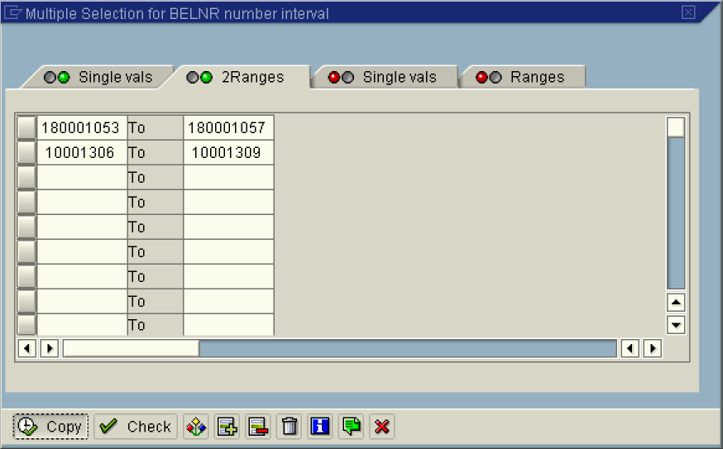

5. Click Single vals .

6. Update the following fields:

Field Name | Field Description | Values
BELNR number interval | In this field you can specify search criteria for incoming payments. The account statement will be searched for FI document numbers. This information is necessary for clearing customer payments. | Example: 10001306 – 10001309

7. Click Copy Button .

Bank Statement: Various Formats (SWIFT, MultiCash, BAI...)

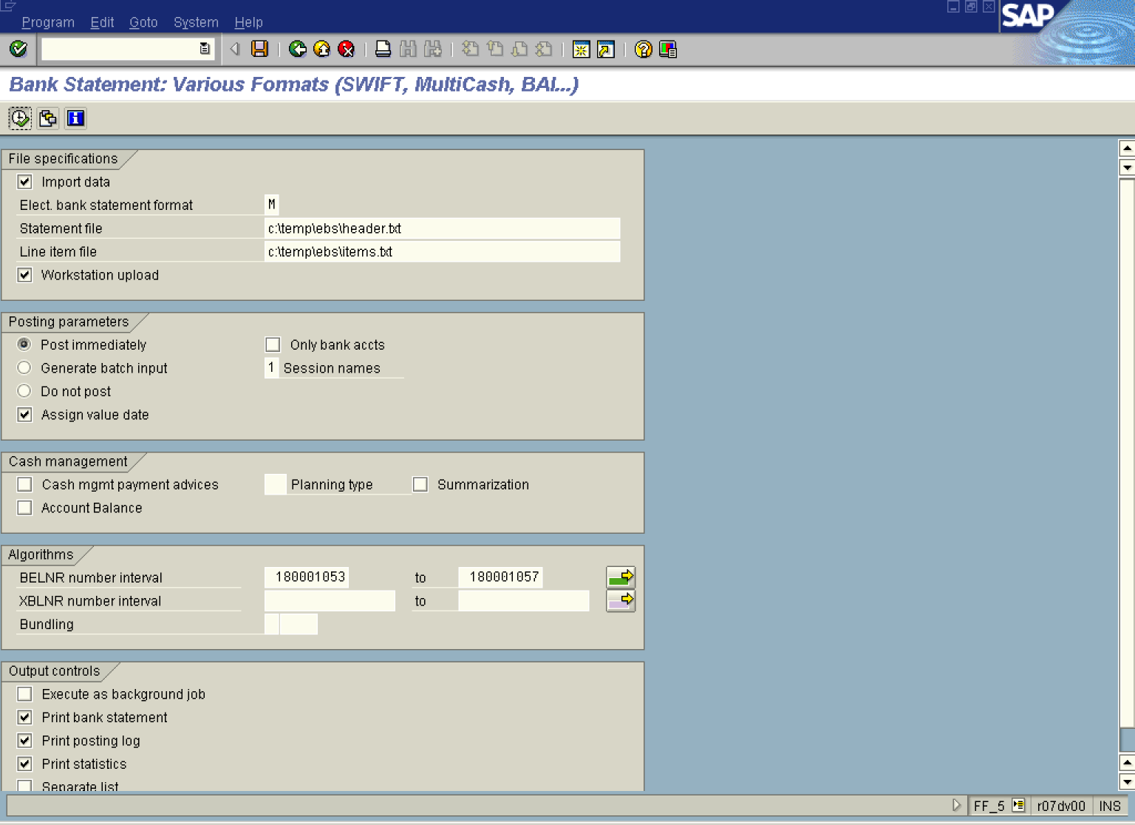

8. Click <checkbox> Print posting log .

9. Click <checkbox> Print statistics .

10. Click <checkbox> Print bank statement .

11. Click Execute button .

Post Bank Statement/Check Deposit List

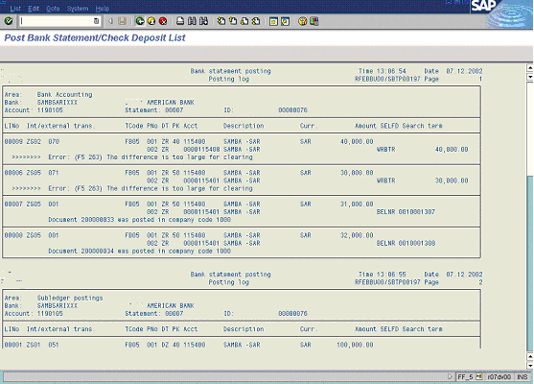

The system has displayed posting log. You can print the log or download it as a local file.

12. Click Back button.

Bank Statement: Various Formats (SWIFT, MultiCash, BAI...)

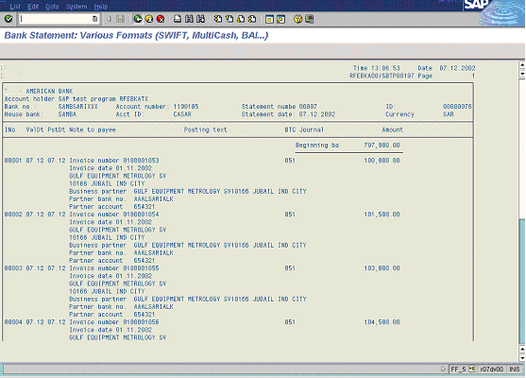

The system has displayed bank statement.

13. Click Back button.
 After posting electronic bank statement use transaction FEBA Postprocess account statement to check have all the documents been posted and post / clear manually some documents, if necessary.

